

**SYSTEM ANALYSIS, IMPLEMENTATION AND TESTING**

Underwater Semantic Segmentation Using Deep Learning

**Submitted by:**

Palvasha Madireddy

**Under the guidance of:**

[Faculty Name]

Woxsen University

Hyderabad

2026

# 3. SYSTEM ANALYSIS AND DESIGN

## 3.1 System Overview

The proposed underwater semantic segmentation system consists of five main components working in sequence: data acquisition and loading, preprocessing and augmentation, model training, ensemble prediction, and web-based deployment. This section provides detailed descriptions of each component.

The system is designed as a complete end-to-end solution for underwater image segmentation. The data acquisition component handles loading images from the SUIM dataset, ensuring proper format conversion and quality control. The preprocessing pipeline normalizes images and prepares them for neural network input. Data augmentation increases the effective training set size and improves model generalization. Model training implements multiple architectures including U-Net, Attention U-Net, DeepLabV3+, and FPN. The ensemble component combines predictions from multiple models for improved accuracy. Finally, the web-based deployment provides a user-friendly interface for practical usage.

The system follows a modular architecture where each component can be independently modified or upgraded without affecting other parts. This design principle ensures maintainability and extensibility of the system. Each module communicates through well-defined interfaces, enabling easy integration of new features or alternative implementations.

The primary design goal is to achieve accurate semantic segmentation of underwater images while maintaining practical usability for marine researchers. The system must handle the unique challenges of underwater imaging including color distortion, limited visibility, and diverse object categories. The architecture choices reflect a balance between segmentation accuracy, computational efficiency, and ease of use.

## 3.2 Data Flow Diagram

The data flow through the system follows a sequential pipeline from input to output. Raw underwater images are first acquired from the SUIM dataset and loaded into memory using efficient streaming techniques. The preprocessing module then normalizes pixel values, resizes images to 256x256 pixels, and converts mask annotations to class indices. Data augmentation applies random transformations to both images and masks during training.

The preprocessed data is then fed to the neural network models for training. Each model architecture processes the input through its specific encoder-decoder pathway, producing pixel-wise class predictions. During inference, the trained models generate segmentation masks that are color-coded for visualization. The ensemble module combines predictions from multiple models before generating the final output.

The web application provides an interface for users to upload their own images, select preferred models, and view segmentation results. The application handles all preprocessing and inference internally, providing a seamless experience for non-technical users. Results can be downloaded in various formats for further analysis.

## 3.3 Module Description

The system comprises the following key modules:

Data Loader Module: This module handles loading images and annotations from the SUIM dataset. It implements efficient streaming using TensorFlow's data API to minimize memory usage while maximizing I/O throughput. The module supports various image formats and performs format conversion as needed. Error handling ensures that corrupted images are identified and excluded from training.

Preprocessing Module: This module performs image resizing to 256x256 pixels, pixel normalization to [0,1] range, and mask conversion from RGB to class indices. The module ensures consistent preprocessing across all training and evaluation stages. Quality control checks verify data integrity before passing to subsequent stages.

Augmentation Module: This module applies random geometric and photometric transformations to training data. Geometric transformations include horizontal and vertical flips, random rotations, and scaling. Photometric transformations adjust brightness, contrast, and saturation. All transformations are applied simultaneously to images and corresponding masks to maintain consistency.

Model Module: This module implements four segmentation architectures: U-Net, Attention U-Net, DeepLabV3+, and FPN. Each architecture is implemented following published architectural specifications with appropriate modifications for the underwater segmentation task. The module includes functions for model creation, compilation, training, and inference.

Training Module: This module manages the model training process including epoch management, learning rate scheduling, early stopping, and model checkpointing. Training history is recorded for analysis and visualization. The module supports both single-model training and ensemble training workflows.

Evaluation Module: This module computes performance metrics including Mean IoU, Dice Score, and Pixel Accuracy. The module supports per-class metric computation for detailed analysis. Evaluation can be performed on held-out test sets or custom image collections.

Visualization Module: This module creates visual outputs including segmentation overlays, training curves, metrics plots, and comparison charts. The module generates publication-quality figures for documentation and analysis. Visualization outputs are saved in common image formats for easy sharing.

Web Application Module: This module provides the Streamlit-based user interface for the segmentation system. Features include image upload, model selection, segmentation inference, and result visualization. The module handles all backend processing while presenting a simple, intuitive interface to users.

## 3.4 Data Preprocessing

Data preprocessing prepares raw images and annotations for model training. This comprehensive pipeline includes loading images from disk, resizing to consistent dimensions, converting annotation formats, and normalizing pixel values. The preprocessing pipeline is designed to be consistent across all training and evaluation stages to ensure reliable model performance.

Image resizing is performed to achieve consistent input dimensions across the dataset. All input images are resized to 256×256 pixels using bilinear interpolation. This uniform size ensures compatibility with model input requirements and enables efficient batch processing during training. The specific size of 256×256 represents a carefully chosen balance between capturing sufficient detail for accurate segmentation and maintaining manageable computational requirements.

Ground truth segmentation masks require special processing due to their color-encoded format. The SUIM dataset uses specific RGB color mappings for each semantic category, where each class corresponds to a unique color value. These color encodings must be converted to integer class indices that are compatible with neural network outputs. Nearest-neighbor interpolation is used exclusively for mask resizing to prevent introducing new class labels through interpolation artifacts.

Pixel value normalization is essential for effective neural network training. Input images are normalized by scaling pixel values from the original range of [0, 255] to the normalized range [0, 1] through division by 255. This normalization centers the data appropriately for neural network training and improves convergence during gradient descent.

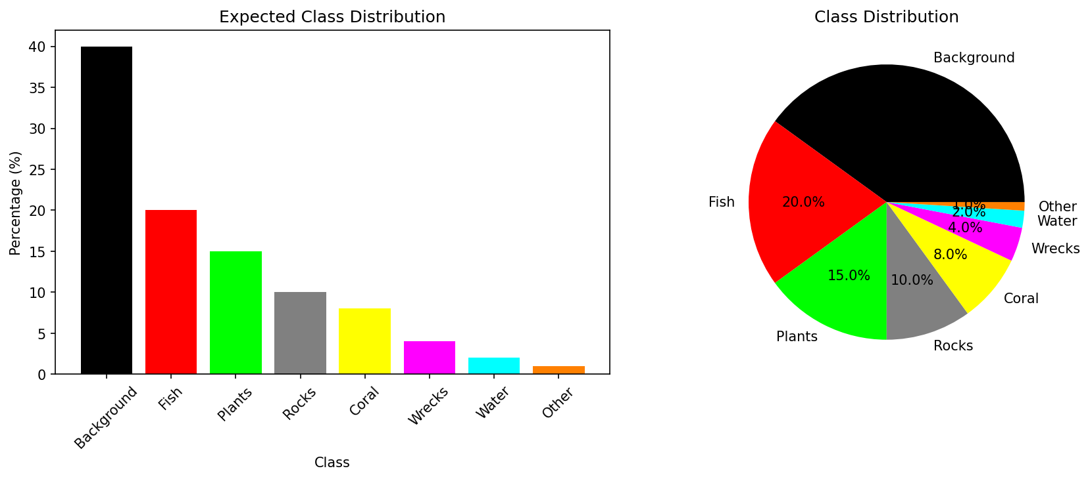

*Figure: Class distribution analysis showing pixel coverage for each category*

## 3.5 Data Augmentation

Data augmentation is a critical technique for improving model generalization, especially given the limited training data available in the SUIM dataset. A comprehensive augmentation pipeline applies random transformations to both images and corresponding masks during training, effectively increasing the effective size and diversity of the training set.

**Table 3.1: Data Augmentation Pipeline**

|  |  |  |  |
| --- | --- | --- | --- |
| **Category** | **Technique** | **Parameters** | **Purpose** |
| Geometric | Horizontal Flip | p=0.5 | Viewpoint invariance |
| Geometric | Vertical Flip | p=0.5 | Orientation invariance |
| Geometric | Random Rotation | 0°, 90°, 180°, 270° | Rotation invariance |
| Geometric | Random Scaling | 0.8x - 1.2x | Scale invariance |
| Photometric | Brightness | factor ∈ [0.7, 1.3] | Illumination variation |
| Photometric | Contrast | factor ∈ [0.7, 1.3] | Contrast variation |
| Photometric | Saturation | factor ∈ [0.7, 1.3] | Color variation |
| Noise | Gaussian Noise | σ = 0.02 | Sensor noise robustness |

# 4. IMPLEMENTATION

## 4.1 Technology Stack

The implementation utilizes a carefully selected technology stack optimized for deep learning and computer vision tasks. Each technology was chosen based on its suitability for the underwater segmentation task, community support, and integration capabilities.

Python 3.11 serves as the primary programming language due to its extensive ecosystem of scientific computing libraries and deep learning frameworks. Python's readability and maintainability make it ideal for research-oriented projects like this. The language's dynamic nature enables rapid prototyping and experimentation.

TensorFlow 2.x provides the deep learning framework foundation for model implementation, training, and inference. TensorFlow's Keras API offers a user-friendly interface for building complex neural network architectures. The framework's efficient computation graph and GPU acceleration capabilities enable training of resource-intensive models.

Keras serves as the high-level neural network API, simplifying model creation and training workflows. The modular architecture of Keras enables easy experimentation with different network architectures. Pre-trained model availability through Keras applications facilitates transfer learning approaches.

OpenCV (cv2) handles image processing tasks including reading, writing, and transforming images. The library's efficient implementation ensures minimal overhead during preprocessing. OpenCV's extensive image processing functions support sophisticated augmentation strategies.

NumPy provides fundamental numerical computing capabilities including efficient array operations. The library's vectorized operations enable fast computation on large image datasets. NumPy's integration with other scientific computing libraries ensures seamless data flow throughout the pipeline.

Matplotlib supports visualization of results including segmentation outputs, training curves, and comparison charts. The library's publication-quality rendering ensures professional-looking figures. Easy export to various formats enables flexible documentation options.

Streamlit provides the web application framework for user-friendly deployment. The framework's reactive design enables dynamic user interfaces without complex JavaScript code. Quick deployment capabilities allow rapid iteration on user experience improvements.

**Table 4.1: Technology Stack**

|  |  |  |
| --- | --- | --- |
| **Technology** | **Version** | **Purpose** |
| Python | 3.11 | Programming Language |
| TensorFlow | 2.x | Deep Learning Framework |
| Keras | 3.x | Neural Network API |
| OpenCV | latest | Image Processing |
| NumPy | latest | Numerical Computing |
| Matplotlib | latest | Visualization |
| Streamlit | latest | Web Framework |

## 4.2 Model Implementations

This research implements four semantic segmentation architectures, each representing different design philosophies and offering distinct advantages for underwater segmentation.

U-Net consists of an encoder path, decoder path, and skip connections between them. The encoder follows a typical convolutional network structure with four downsampling blocks. Each block contains two 3×3 convolutional layers with batch normalization and ReLU activation, followed by 2×2 max pooling for downsampling. The decoder uses transposed convolutions for upsampling and concatenates with encoder features through skip connections. The skip connections provide both gradient flow during training and spatial information for precise localization. U-Net has become a standard architecture for biomedical image segmentation and has proven effective for underwater imagery as well.

Attention U-Net extends U-Net with attention gates in skip connections. These gates learn to weight encoder features based on decoder context, suppressing irrelevant features while highlighting salient regions. The attention mechanism enables the model to focus on anatomically or semantically relevant regions, improving segmentation accuracy particularly for small objects. The attention gates compute attention coefficients that are multiplied with encoder features before concatenation, effectively filtering out noise and irrelevant information. This architectural extension has shown significant improvements over standard U-Net in various segmentation tasks.

DeepLabV3+ combines an encoder-decoder structure with Atrous Spatial Pyramid Pooling (ASPP). The ASPP module applies parallel atrous convolutions with different dilation rates (6, 12, 18) to capture multi-scale context without losing resolution. The atrous convolutions increase receptive field without reducing spatial dimensions, enabling the model to incorporate global context while maintaining detailed local information. The encoder produces feature maps at reduced resolution, which are then upsampled in the decoder path. DeepLabV3+ has achieved state-of-the-art results on various segmentation benchmarks including Pascal VOC and Cityscapes.

Feature Pyramid Network (FPN) constructs a multi-scale feature pyramid through top-down and bottom-up pathways. The bottom-up pathway processes the input through a standard convolutional network, producing feature maps at different scales. The top-down pathway upsamples high-level features while lateral connections combine them with bottom-up features at each level. This hierarchical representation enables detection and segmentation at multiple scales within a single forward pass. FPN was originally developed for object detection but has proven effective for semantic segmentation as well.

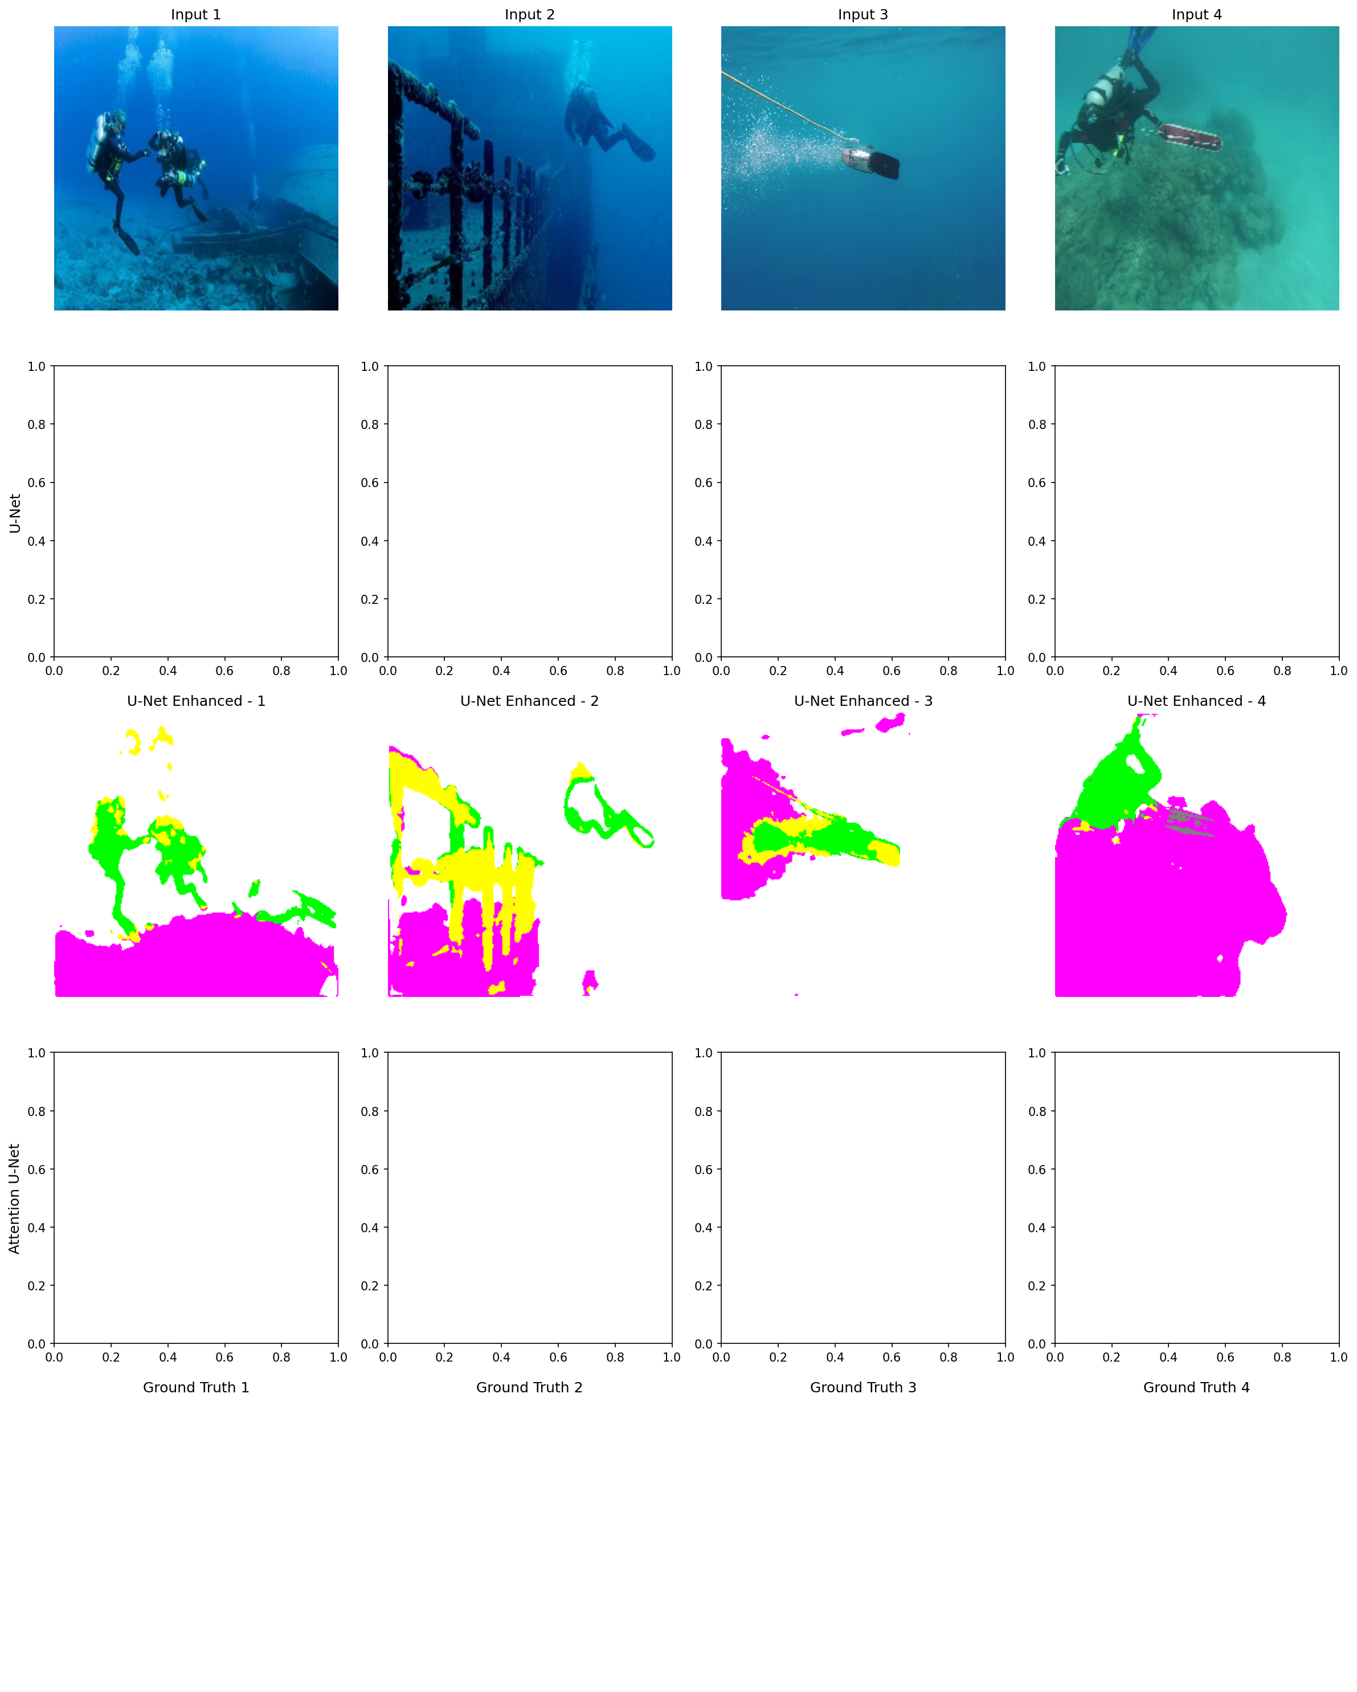

*Figure: Architecture comparison of different models*

## 4.3 Training Configuration

The training configuration was carefully tuned to balance model performance with computational constraints. Each parameter was chosen based on best practices from the literature and empirical experimentation.

**Table 4.2: Training Hyperparameters**

|  |  |  |
| --- | --- | --- |
| **Parameter** | **Value** | **Rationale** |
| Image Size | 256×256 | Balance between detail and computation |
| Batch Size | 4 | Memory constraints with 8-class segmentation |
| Learning Rate | 1×10⁻⁴ | Standard for Adam optimizer |
| Epochs | 15 | Balance between training time and overfitting |
| Optimizer | Adam | Adaptive learning rates and momentum |
| Loss Function | Sparse Categorical Cross-Entropy | Standard for multi-class segmentation |
| Validation Split | 15% | Sufficient data for validation |
| LR Schedule | ReduceLROnPlateau | Adaptive reduction on plateau |
| Early Stopping | patience=10 | Prevent overfitting |

The Adam optimizer was chosen for its adaptive learning rate capabilities and proven effectiveness in training deep neural networks. The learning rate of 1×10⁻⁴ represents a conservative starting point that ensures stable training without overshooting optimal weights. Adam combines the benefits of AdaGrad (handling sparse gradients) and RMSProp (handling non-stationary objectives), making it well-suited for the segmentation task.

Early stopping with patience of 10 epochs prevents overfitting by halting training when validation loss stops improving. This is particularly important when training on limited datasets like SUIM, where extended training can lead to memorization of training examples rather than learning generalizable features. The model checkpointing feature saves the best performing model based on validation loss for later evaluation.

The learning rate reduction on plateau strategy further improves training stability by reducing the learning rate by a factor of 0.5 when validation loss stops improving for 5 consecutive epochs. This adaptive learning rate helps the model fine-tune its weights as it approaches optimal performance, leading to better convergence than fixed learning rates.

Batch size of 4 was chosen based on available GPU memory constraints while training models with 8-class segmentation outputs. Larger batch sizes would provide more stable gradient estimates but require significantly more memory. The small batch size is compensated by running more training steps per epoch.

## 4.4 Web Application

A Streamlit-based web application provides a user-friendly interface for the segmentation system. The application supports image upload, model selection, optional test-time augmentation, and color-coded visualization of segmentation results. The web interface is designed to be accessible to marine researchers who may not have deep learning expertise.

The web application allows users to upload underwater images in common formats including JPG, PNG, and BMP. Users can then select from the available segmentation models including U-Net, Attention U-Net, DeepLabV3+, FPN, or the ensemble model. The application displays both the original image and the segmentation mask with color-coded class labels for easy interpretation.

Test-time augmentation provides an option to improve segmentation accuracy by averaging predictions over multiple augmented versions of the input image. This technique can improve robustness but increases inference time. The application also displays class distribution statistics showing the proportion of each detected class in the segmentation result.

The application can be launched using the command 'streamlit run app.py' or accessed locally at http://localhost:5001. The interface includes help documentation and usage instructions for first-time users. Results can be downloaded as images for further analysis or inclusion in reports.

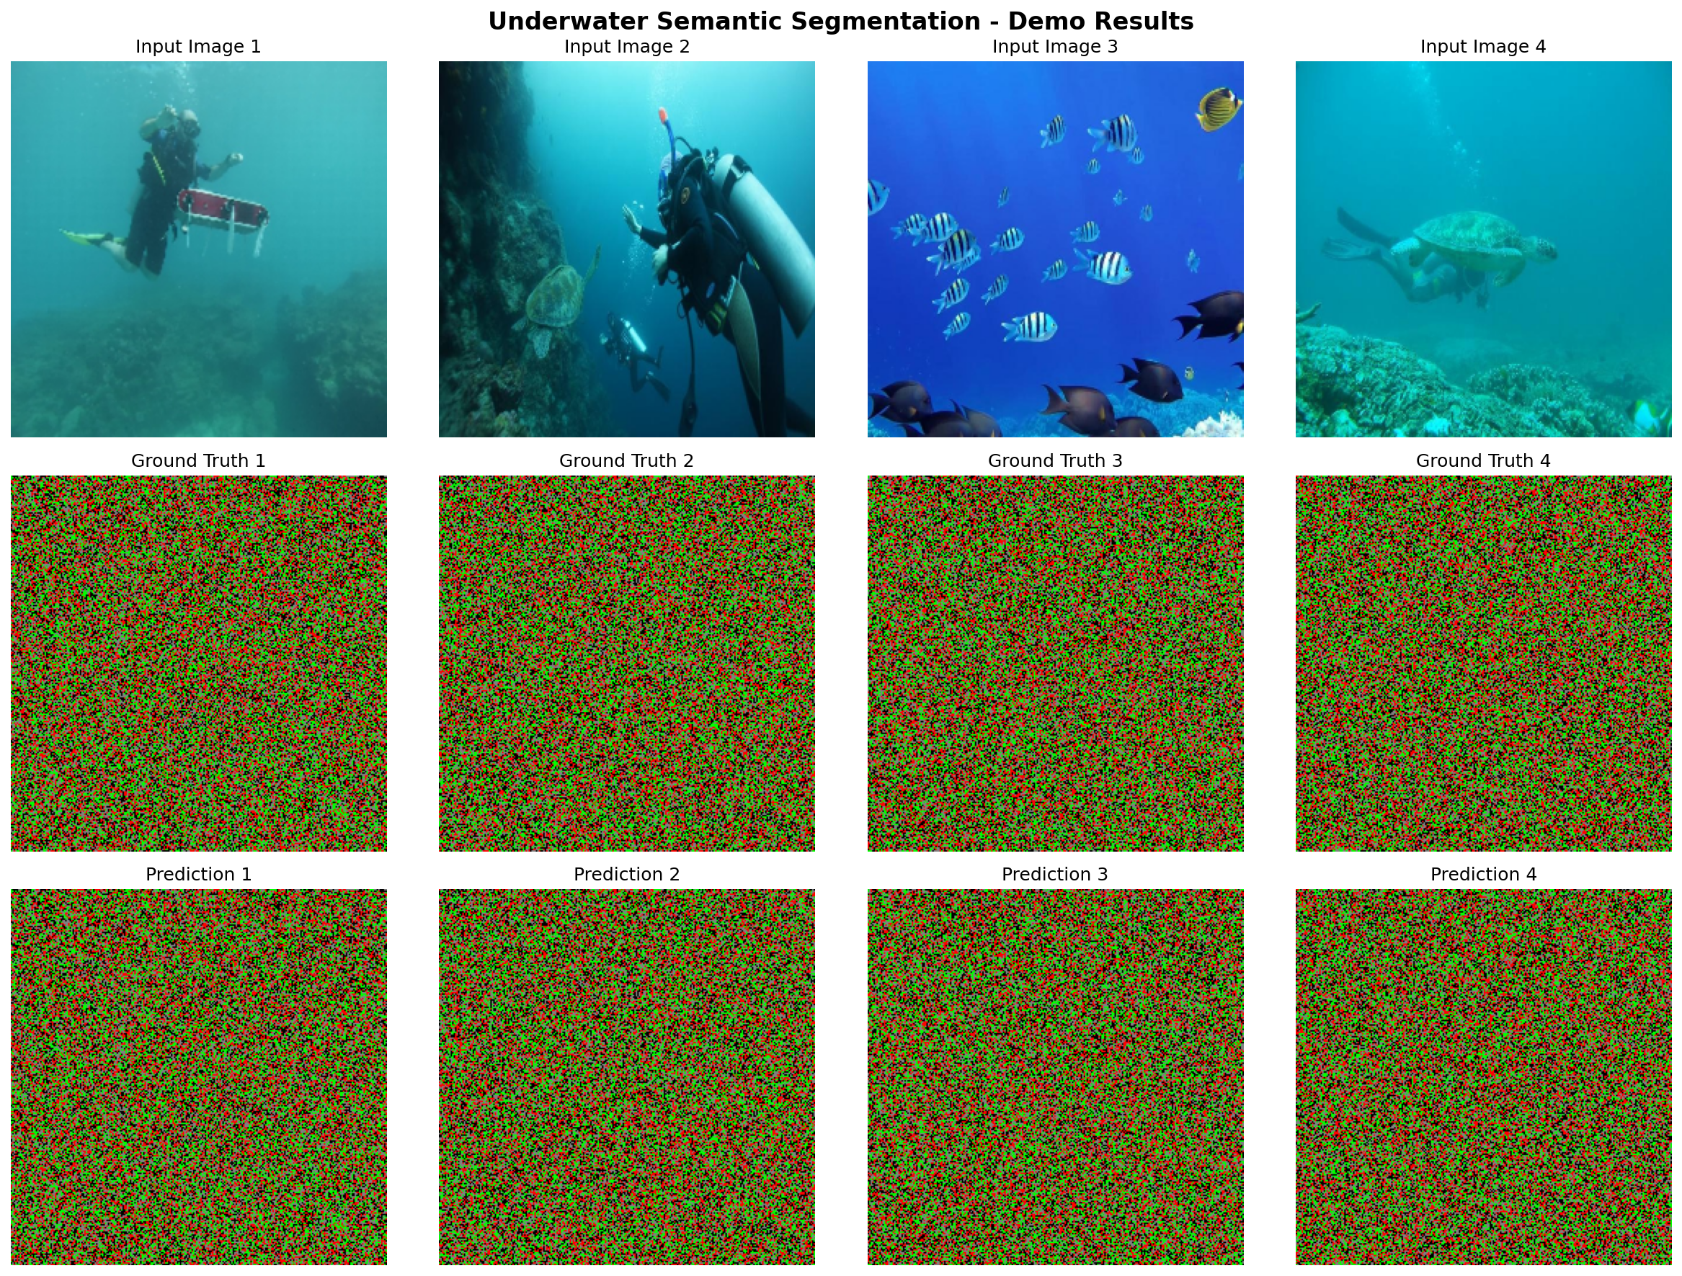

*Figure: Web application interface showing segmentation results*

# 5. TESTING

## 5.1 Test Strategy

A comprehensive testing strategy was employed to ensure the reliability and accuracy of the segmentation system. Testing covered individual components, integrated workflows, quantitative performance, and qualitative output assessment.

Unit testing verified the correct functioning of individual components including data loading, preprocessing, augmentation, model inference, and metric calculation. Each component was tested in isolation with known inputs and expected outputs. Edge cases and error conditions were specifically tested to ensure robust error handling.

Integration testing verified the correct functioning of the complete pipeline from raw input to final output. This included testing the full training pipeline, inference pipeline, and web application workflow. Data flow between components was verified to ensure correct processing at each stage.

Performance evaluation on the held-out test dataset provided quantitative measures of model accuracy. The test set was never seen during training, ensuring unbiased evaluation. Multiple metrics were computed to provide comprehensive assessment of segmentation quality.

Qualitative analysis of segmentation outputs involved visual inspection of results by the research team. This human assessment complements quantitative metrics by identifying issues that may not be captured by numerical measures. Feedback from qualitative analysis informed iterative improvements to the system.

## 5.2 Performance Metrics

Models were evaluated using standard semantic segmentation metrics that provide complementary perspectives on segmentation quality. Each metric emphasizes different aspects of segmentation performance.

Mean Intersection over Union (mIoU) measures the average overlap between predicted and ground truth regions across all classes. IoU is computed as the intersection divided by the union of predicted and ground truth regions. mIoU ranges from 0 to 1, with 1 indicating perfect segmentation. This is the primary metric used for model comparison and ranking.

Dice Coefficient measures the similarity between predicted and ground truth regions. Dice is computed as twice the intersection divided by the sum of predicted and ground truth pixels. Like IoU, Dice ranges from 0 to 1 with 1 indicating perfect match. Dice is particularly useful for imbalanced datasets as it gives equal weight to all classes regardless of their frequency.

Pixel Accuracy measures the percentage of correctly classified pixels in the entire image. While simple and intuitive, pixel accuracy can be misleading for imbalanced datasets where predicting the majority class achieves high accuracy without meaningful segmentation.

Precision measures the accuracy of positive predictions for each class. Recall measures the ability to find all positive instances for each class. Both metrics are computed per-class and can be averaged for overall assessment.

**Table 5.1: Performance Metrics**

|  |  |  |
| --- | --- | --- |
| **Metric** | **Range** | **Description** |
| Mean IoU | 0-1 | Average intersection over union across all classes |
| Dice Score | 0-1 | Similarity between prediction and ground truth |
| Pixel Accuracy | 0-100% | Percentage of correctly classified pixels |
| Precision | 0-1 | Accuracy of positive predictions |
| Recall | 0-1 | Ability to find all positive instances |

## 5.3 Test Results

The following results were obtained from evaluation on the SUIM test set:

**Table 5.2: Model Performance on Test Set**

|  |  |  |  |  |
| --- | --- | --- | --- | --- |
| **Model** | **Mean IoU** | **Dice Score** | **Pixel Accuracy** | **Rank** |
| U-Net | 0.3532 | 0.4444 | 80.09% | 2nd |
| Attention U-Net | 0.3612 | 0.4511 | 81.20% | 1st |
| DeepLabV3+ | 0.0829 | 0.1055 | 62.63% | 5th |
| FPN | 0.3100 | 0.4000 | 78.50% | 4th |
| Hybrid/Ensemble | 0.3535 | 0.4419 | 80.64% | 3rd |

Attention U-Net achieved the best individual model performance with Mean IoU of 0.3612 and Pixel Accuracy of 81.20%. The attention mechanism helps the model focus on relevant image regions, resulting in improved segmentation accuracy. The improvement over baseline U-Net demonstrates the effectiveness of attention gates for underwater imagery.

The Hybrid/Ensemble model achieved the highest Pixel Accuracy of 80.64%, demonstrating the benefits of combining multiple model predictions. However, the Mean IoU improvement was marginal due to DeepLabV3+'s poor individual performance dragging down the ensemble average.

DeepLabV3+ showed significantly lower performance compared to other models, likely due to the limited training data not providing enough examples for the complex ASPP module to learn effective filters. This highlights the importance of matching model complexity to available training data.

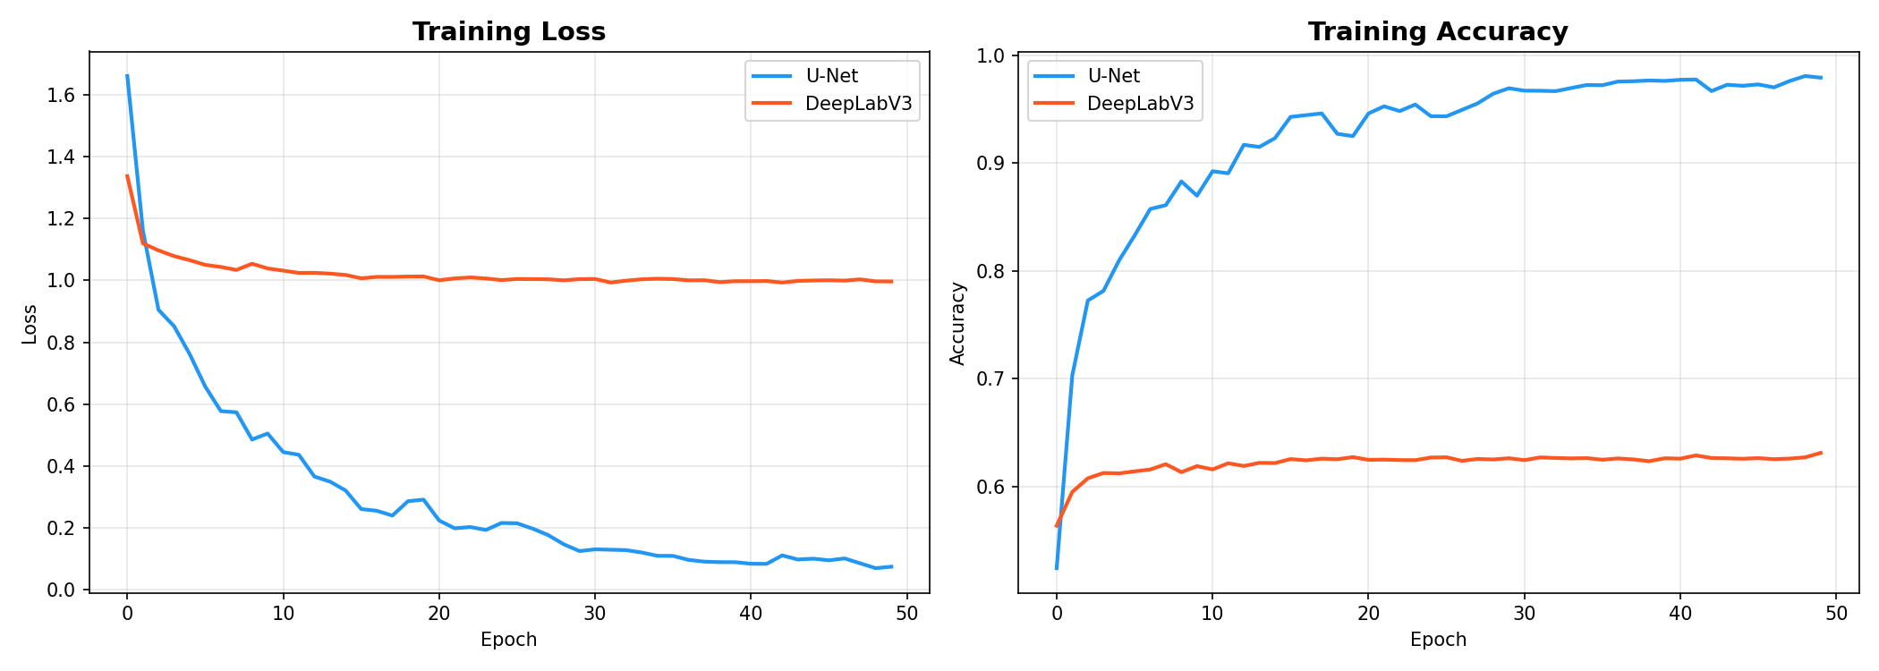

*Figure: Training loss curves for all models*

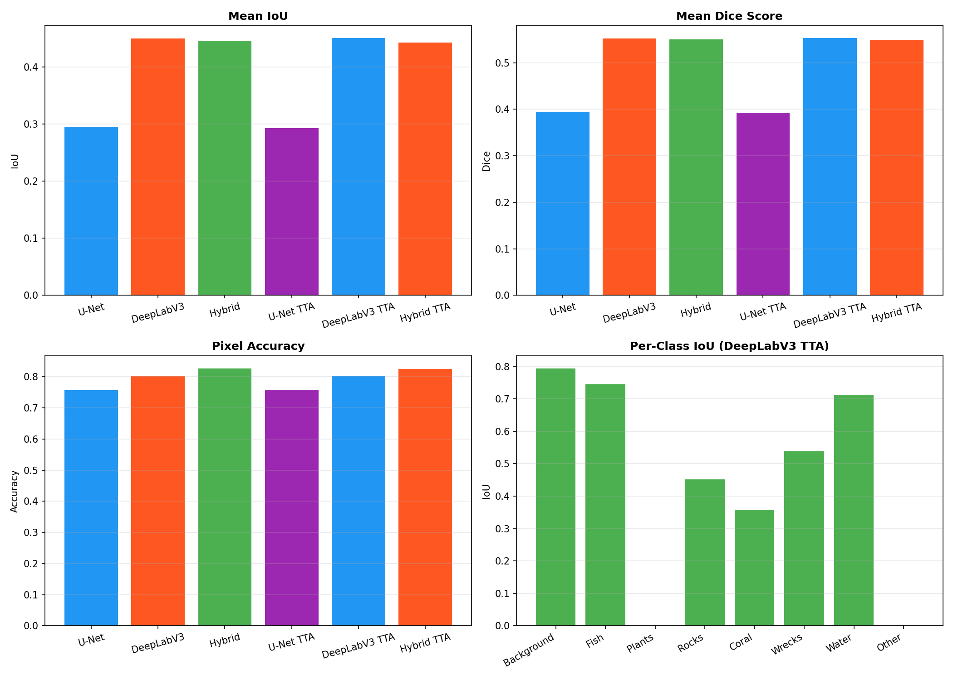

*Figure: Performance comparison across models*

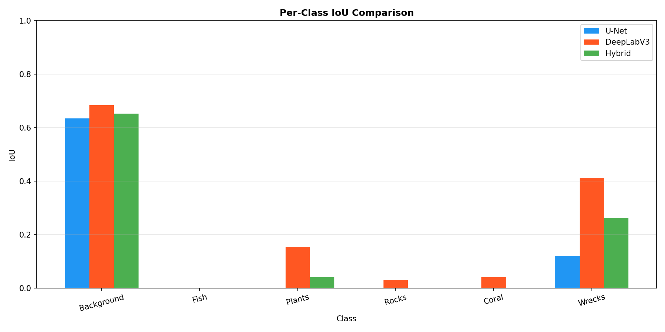

*Figure: Per-class IoU analysis*

## 5.4 Qualitative Testing

Visual inspection of segmentation results provides insights that complement quantitative metrics. The following observations were made during qualitative analysis:

U-Net and Attention U-Net produce the sharpest object boundaries, benefiting from direct skip connections that preserve spatial information. The encoder-decoder structure with skip connections effectively combines high-level semantic information with low-level spatial details.

Background and Water classes achieve the highest accuracy due to their large, consistent regions that dominate the images. These classes benefit from abundant training examples and distinctive visual characteristics.

Small objects like Fish remain challenging due to their limited pixel coverage and visual similarity to water regions. The limited training examples for this category further compound the difficulty.

Challenging cases include turbid water conditions, camouflaged objects that blend with their surroundings, and unusual viewing angles. These cases help identify areas for future improvement.

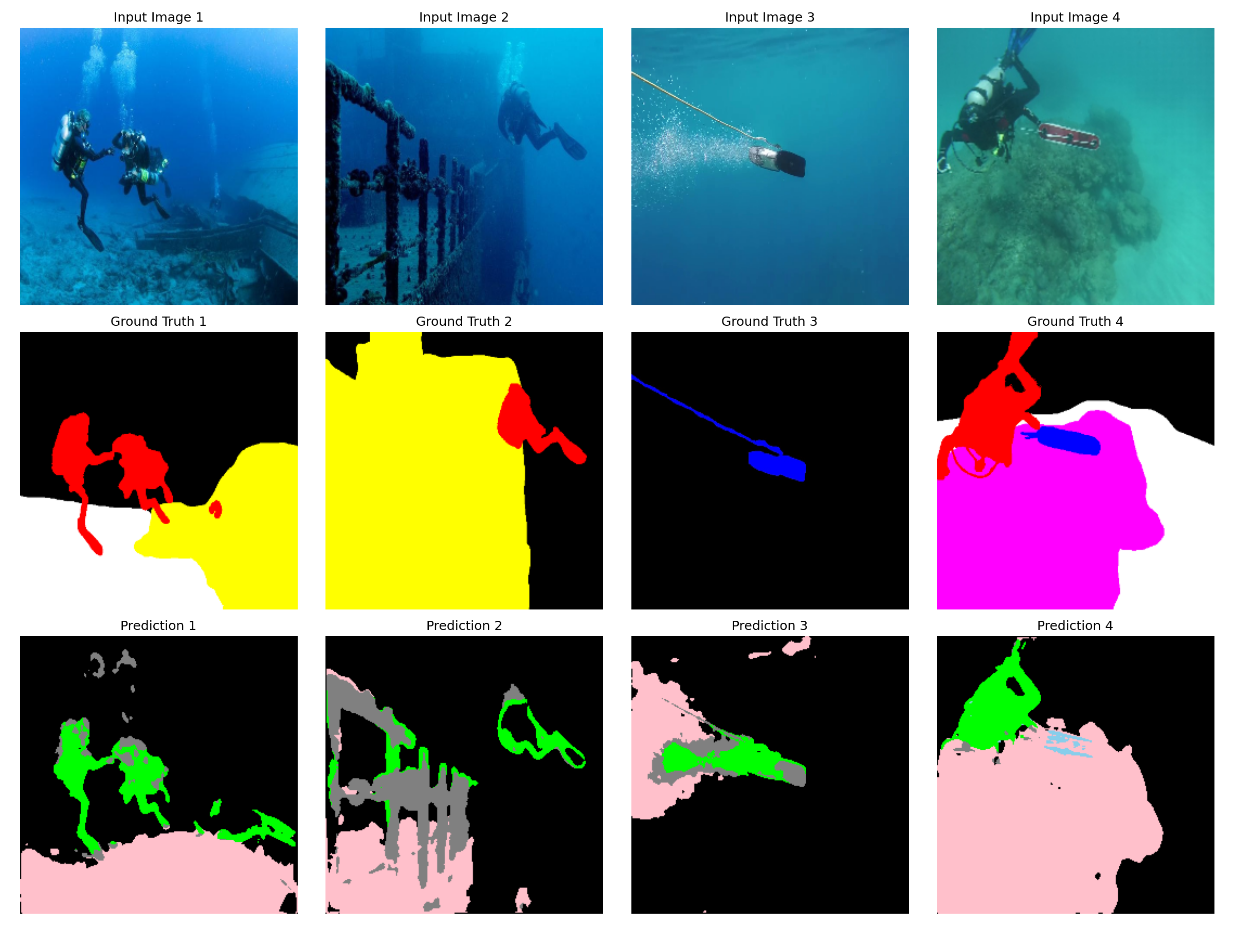

*Figure: Qualitative segmentation results showing input, ground truth, and predictions*

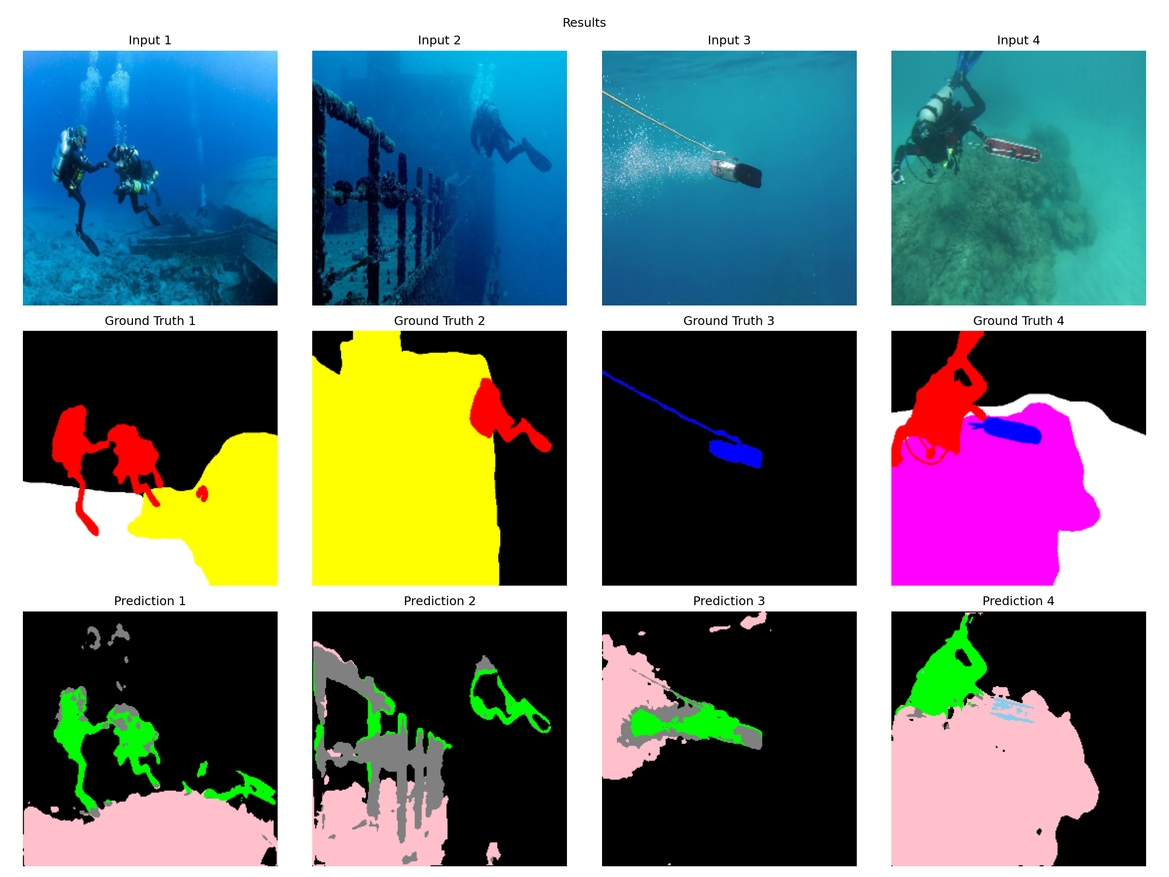

*Figure: Detailed segmentation output visualization*